|  |
| --- |
| 2022 Survey Results |
| r/FinancialIndependence Annual Survey |

|  |
| --- |
|  |



|  |
| --- |
| 2022 Survey Results |
| r/FinancialIndependence Annual Survey |
| Introduction Over the last decade there has been a growing trend in working-class people looking to leave the workplace behind and live the life they’ve always envisioned. The Financial Independence, Retire Early (FIRE) movement focuses on maximizing income while reducing expenses and saving the difference to build enough wealth to live off in perpetuity. Several communities of people following this path have grown over this time, a major one being Reddit’s r/financialindependence subreddit. Here, like-minded individuals from all over the world congregate to discuss their financial goals, share successes and failures, and crowd-source personal finance approaches that enable one to achieve FIRE.  Within the past few years, it has become an annual tradition to survey the subreddit and gather a general overview of the community. Most of the questions address demographic information while others focus on the finances of each household. This report takes the results from the survey, which consisted of 1365 respondents over 100+ questions, and presents its findings for the year 2022. Methods Data was cleaned to remove blank responses. Not every respondent answered every question and blank responses were removed from analysis. Respondents answered in multiple currencies, so currency data was standardized to USD by converting other currencies to USD based on their current exchange rates. As a number of high-end outliers were present in numerical data (e.g. FI number of 250 million), responses in the top 1% of values were removed, as were responses of “0”. Demographics US vs. Non-US – The vast majority of respondents were located within the US (89.5%) whereas only 10.5% were non-US residents.  Number of Contributors – This question asked how many people in each household contributed to the total income. There was a near equal amount of single-income and dual-income households (51.6% and 48.9% respectively), with only 0.5% of respondents reporting a household with 3 or more contributors. |

Marital Status – The primary respondent was overwhelmingly married (50.3%), though unwedded couples and single individuals were almost equal (26.5% and 23% respectively) albeit lower. Overall, 3.8% had been divorced and 0.2% had been widowed.

Number of Contributors by Marital Status – Of the married respondents, 81.4% reported being a dual-income household, while only 18.3% were single-income and 0.3% being triple-income. On the other hand, those in a relationship but not married reported most being single-income households over dual-income (74.2% vs. 25.8%).

Age Range – The primary respondent’s age range gave a right-skewed normal distribution, with a median age of 31-35. Most respondents were in the early to mid-career age range (25-40, 74.8%). The median age range of respondents who already achieved FI was slightly higher at 41-45 while the median age range of respondents who had not achieved FI matched the overall distribution at 31-35.

For secondary respondents, the median age range was equivalent to the primary respondent at 31-35, and the distributions were near equivalent. Median age ranges were equivalent to the primary respondent for both those who had and had not achieved FI (41-45 and 31-35 respectively).

Gender – The primary respondent was overwhelming male (78.5%) with females and non-binary respondents being in the minority (20.6% and 0.9% respectively). Secondary respondents were mainly female (68.8%) with males and non-binary being the minorities (30.5% and 0.7% respectively).

Ethnicity – Of the primary respondents, 72.8% were White, 13.6% were Asian, and the remaining 13.6% being of 29 other ethnic backgrounds. Similarly, 71.8% of secondary respondents were White, 15.9% were Asian, and the remaining 12.3% were made up of 15 other ethnic backgrounds.

Children – There was a nearly equivalent distribution over respondents that have children, do not have children but intend to, do not have children and do not intend to, and do not have children and are undecided (26.7%, 26.4%, 25.6%, and 21.3%). Married couples overwhelmingly had children or intended to have children (49.3% and 23.9% respectively). Unwedded couples mainly had no children (97.2%) and were evenly divided between whether they would have them or not (38% and 32.1%) while a slightly lower amount were undecided about having future children (27.1%).

Single respondents were mainly undecided about future children (43.9%) though those who had decided favored not having children over having them (35.1% to 21%).

Those who had children almost evenly had either 1 or 2 children (45.4% and 42.1%) with only 2.5% of respondents reporting having 3 or more children. Respondents with 1 child were evenly split between having 0 or 1 additional child (42.5% and 44.5%) with 13% wanting 2 or more additional children. Those with 2 overwhelming wanted 0 additional children (81.8%) though 8% and 10.2% of respondents wanted 1 and 2 additional children respectively. Most respondents with 3 or more children wanted 0 additional children (81.5%), though 18.5% wanted at least 1 more.

Respondents without children but who intended to have them mainly wanted 2 children (65.6%) with smaller minorities wanting either 1 or 3 (13.1% and 18.8%). 2.5% of childless respondents wanted to have 4 future children.

Education – Majorities of both primary and secondary respondents had at least a 4-year undergraduate degree (92.3% and 90.5% respectively). Of the total of both primary and secondary respondents, 50.4% had up to a Bachelor’s degree, 30.8% had a Master’s degree, and 10.6% had their Doctorate degree.

Industry – The vast majority of primary respondents work in information technology (31.8%) with engineering, financial services, and healthcare as the next largest sectors (11.9%, 10.6%, and 10.3% respectively). Secondary respondents were mainly in healthcare (22%), followed by IT (17.1%) and education (13%).

Most respondents work in private industry (87.8%) over public agencies (12.2%), with 44.3% working for private corporations and 30.6% working for public corporations. 8.6% reported working for non-profits while 4.3% were self-employed.

Political Lean – On a 0-100 scale, with lower numbers being politically left wing and higher numbers being right wing, the average respondent scored a 36.5 and the median response was 32, which is reasonably left leaning. 59.4% viewed themselves as left-wing (<40), 14.5% were right-wing (>60), and 26.1% were moderates (40-60).

Cost of Living Index – Cost-of-living index was selected from Numbeo’s cost-of-living database. Most respondents live in an area with a cost-of-living index between 81-90 (33.9%) or 71-80 (30.3%). 16.2% live in areas that rank between 91-100 while 10.7% live in areas between 61-70.

NOTE: The ranges provided cover a wide array of locations (e.g. 81-90 covers Raleigh, NC up to San Diego, CA while 71-80 covers both Toronto, Canada and Detroit, MI) and may not be indicative of actual cost-of-living.

Residence – 58.4% of respondents own their own home while 34.8% rent. 5.9% live with either their family or friends while just 0.6% are nomadic and 0.2% live in a residence provided by their employer, school, or the military.

### FIRE vs. Non-FIRE

Financially Independent / Retired Early – 88% of respondents had yet to reach financial independence while 12% were FI. Of those who were FI, only 15.5% had retired while 84.5% remained working.

Of those who reached their FI number, 42.2% were “normal” FI, 30.9% were ChubbyFI, 13.4% were FatFI, 1% were LeanFI, and 2.1% were Barista/Coast FI.

For those who had retired early, 50% were normal” FI, 26.3% were LeanFI, 11.4% were Barista/Coast FI, 7.9% were ChubbyFI, and only 0.9% were FatFI.

From those who have yet to reach their FI number, 51.5% were aiming for “normal” FI, 24.1% aimed for ChubbyFI, 7.6% for Barista/Coast FI, 4.7% for FatFI, and 4.3% for LeanFI.

Of those who had yet to reach their FI number, 23.3% said they would retire early once FI was reached while 33.7% would partially retire and 18.5% wouldn’t retire.

Expected Retirement Age – Of all respondents, a near even split estimate that they will retire between either 41-45 (22.8%), 46-50 (22.9%), or 51-55 (22.4%). 15.4% expect to retire in their 30s while 12.5% do not expect to retire until at least age 56.

The distribution of expected retirement ages does not vary when isolating only individuals who have yet to reach their FI number. However, of those who have reached their FI number, 28.9% expect to retire at 41-45 while 16.5% expect to retire at 36-40 and 14.4% at 46-50. An additional 16.5% expect to retire at 51-55.

### FIRE by the Numbers: Non-FI Respondents

Financial Independence Number – The average and median reported FI numbers were $2.18 million and $2.0 million respectively (excluding top 1%). 95% of all respondents had FI numbers ranging up to and including $5 million.10.1% of respondents had FI numbers less than $1 million and 2.8% had FI numbers above $5 million. The majority of respondents are aiming for between $1 million and $3 million (75.3%).

Married respondents on average needed $2.48 million to be FI (median $2.5 million) while single respondents needed 33.7% less: $1.71 million on average (median $1.5 million). Unwedded couples required $2.0 million on average (median $1.6 million).

Those with children required $2.61 million on average (median $2.5 million) to be considered FI while respondents who do not want children required 29.9% less: $1.83 million on average (median $1.58 million).

The average and median FI numbers were $955k / $1 million (LeanFI), $1.59 million / $1.3 million (Barista / CoastFI), $1.9 million / $1.8 million (FI), $2.79 million / $2.5 million (ChubbyFI), and $3.8 million / $3.5 million (FatFI). Those who were undecided aimed for $2.3 million (median $1.5 million).

Early Retirement Number – The average and median RE numbers were a bit higher than the corresponding FI numbers, $2.83 million and $2.2 million respectively. On average, a respondent’s RE number was 35.6% higher than their FI number, with the median being equivalent. 8.2% expected to retire with below $1 million while 7.8% would retire with over $5 million. 84% planned to retire with between $1 million and $3 million.

Percent to Financial Independence – The average respondent was 28.7% of the way to their FI number, with the median being slightly lower at 25%. 80.7% of respondents were less than halfway to their goal.

Married respondents were closer to FI on average (32.8%, median 30%) compared to single respondents (23.6%, median 20%) and unwedded couples (23.7%, median 20%).

Safe Withdrawal Rate – 90.2% of respondents are aiming for a safe withdrawal rate between 3 and 4%, with the average and median rates being 3.57% and 3.5% respectively.

Expected Retirement Income – 87.3% of respondents expected to have $100k or less in annual income in retirement. The average estimated income was $58.8k per year while the median response was only $40k per year. The maximum expected income was $550k per year (excluding top 1%). 25.3% of respondents plan to retire with $20k per year or less while 18.4% plan to retire with $100k per year or more.

Married couples required $65k per year on average (median $45k), 31% more than single respondents (mean $49.5k, median $30k) and 19% more than unwedded couples (mean $54.6k, median $30k).

Similarly, respondents who have children required higher annual income in retirement (mean $68k, median $48k) compared to those who do not and do not intend to have them (mean $48.5k, median $30k).

Expected Retirement Expenses – 78.9% of respondents expected to spend $100k or less per year in retirement. The average estimated expenses were $84.5k per year while the median was slightly lower at $75k per year. Only 1.8% of respondents expected to spend $20k or less per year in retirement while 21.1% expected to spend over $100k per year.

Married couples expected to spend $96.4k per year on average (median of $88.5k) while single respondents averaged $64.7k per year (median $60k) and unwedded couples averaged $77k (median $70k).

Respondents with children expected to spend $101.2k per year on average (median $90k), or approximately 38.2% more than those without and not intending to have children ($73.2k per year on average, median $60.6k).

### FIRE by the Numbers: FI Respondents

Financial Independence Number – Of those respondents who had reached FI, the average and median reported FI numbers were $1.92 million and $1.6 million respectively. 27.6% of FI respondents reported being FI at $1 million or less while 2.8% reported being FI at $5 million or more.

Married, FI respondents reported needing $2.13 million on average (median $2 million) to be FI while single respondents needed $1.96 million on average (median $1.5 million) and unwedded couples required $1.28 million (median $1.35 million).

FI respondents with children needed $2.32 million on average (median $2 million) to consider themselves FI while child-free retirees required 25.9% less: $1.72 million on average (median $1.5 million).

Of those considered FI, 27.6% were LeanFI, 11.4% were Barista / CoastFI, 50.5% were FI, 5.7% were ChubbyFI, and 1.0% were FatFI. The average and median FI numbers for each were $1.2 million / $1 million (LeanFI), $1.62 million / $1.49 million (Barista / CoastFI), $2.17 million / $2 million (FI), $3.29 million / $2.75 million (ChubbyFI), and $5 million / $5 million (FatFI).

Early Retirement Number – Only 15.5% of FI respondents had retired early. Of those, the average and median early retirement numbers were $2.54 million and $2 million.

Safe Withdrawal Rate – Retired respondents withdrew 1.98% per year on average (median 1.8%). 61.5% withdrew what they expected this year while 30.8% withdrew less and 7.7% withdrew more. The average and median annual withdrawal amounts were $53k and $50k per year.

### Personal Finances

Assets – The average total asset value for all respondents was $1.14 million (median $850k). 55.9% had assets less than $1 million and only 0.7% had assets over $5 million. On average, a respondent’s primary residence is 30.5% of their total asset value (median 28.9%), retirement accounts are 36.8% (median 33.9%), brokerage accounts are 22.2% (median 15.2%), and cash is 9.1% (median 4.6%). 41.5% of respondents had speculative assets (e.g. crypto, individual stocks) and 19.8% had rental properties or business assets.

Respondents who were not yet financially independent averaged $979k in total assets (median $750k) compared to the average of $2.48 million (median $2.23 million) for FI respondents. Both FI and non-FI respondents had a similar percentage of their total assets in retirement accounts (mean 36% to 36.9%, median 32.2% to 34.2%), but differed on primary residence (mean 17.9% to 32.1%, median 18.2% to 33.3%) and brokerage accounts (mean 34.2% to 20.6%, median 34.4% to 13.5%).

By age range and relationship status, the mean and median total asset values are listed below:

|  |  |  |  |  |  |  |
| --- | --- | --- | --- | --- | --- | --- |
|  | **All Respondents** | | **Single** | | **Married** | |
| **Age Range** | **Mean** | **Median** | **Mean** | **Median** | **Mean** | **Median** |
| <20 | $261k | $14.8k | $343k | $15k | - | - |
| 21 – 25 | $366k | $176k | $204k | $148k | $508k | $550k |
| 26 – 30 | $574k | $420k | $384k | $260k | $890k | $726k |
| 31 – 35 | $1.06m | $857k | $691k | $664k | $1.22m | $1.01m |
| 36 – 40 | $1.64m | $1.47m | $1.33m | $947k | $1.73m | $1.55m |
| 41 – 45 | $1.82m | $1.6m | $1.71m | $1.72m | $1.98m | $1.72m |
| 46 – 50 | $2.58m | $2.52m | $1.56m | $1.56m | $2.84m | $3m |
| 51- 55 | $2.52m | $2.23m | $2.46m | $2.24m | $2.63m | $2.55m |
| 56 – 60 | $3.2m | $3.12m | $1.6m | $1.6m | $3.28m | $3.15m |
| 61 – 65 | $3.72m | $3.72m | - | - | $3.72m | $3.72m |

Single respondents averaged $702k in assets (median $501k), unwedded couples averaged $737k (median $450k), while married couples averaged $1.49 million (median $1.19 million).

Respondents with children had an average of $1.72 million in assets (median $1.49 million) while child-free respondents averaged $1.11 million (median $823k). There was a minimal difference between total assets of married couples with children and those that are child-free (mean $1.73 million vs. $1.53 million, median $1.52 million vs. $1.41 million).

The primary residence of home-owning respondents was worth an average of $576k (median $490k). 12.2% of homeowners lived in a house worth $1 million or more while 60.4% lived in homes worth $250k or less.

Of respondents who had any investments, the average total balance (retirement + brokerage + dedicated savings + speculative investments) was $664k (median $409k). Average values for accounts with active balances were $377k (median $258k) for retirement accounts, $304k (median $120k) for brokerage accounts, $32k (median $15k) for dedicated savings accounts (e.g. HSA, 529), and $43.4k (median $5k) for speculative investments.

Income – The average total income of respondents was $213.6k (median $180k). 70.3% of respondents had all their total income come from wages while 1.7% received all their income from self-employment.

Married couples had approximately double the average income of single respondents (mean $263k vs. $138k, median $233k vs. $119k). However, there was little difference between the income of married couples with children and those who were child-free (mean $269k vs. $271k, median $235k vs. $234k).

73% of respondents had only a single source of income, 22.7% had 2 sources, 4.1% had 3 sources, and 0.3% had 4 sources. In addition to their normal wages, 10.2% had additional self-employment income, 8.3% had additional rental property or business income, and 13.4% had additional other income.

The average and median total incomes of each age range and relationship status is summarized below:

|  |  |  |  |  |  |  |
| --- | --- | --- | --- | --- | --- | --- |
|  | **All Respondents** | | **Single** | | **Married** | |
| **Age Range** | **Mean** | **Median** | **Mean** | **Median** | **Mean** | **Median** |
| <20 | $90k | $22k | $112k | $21k | - | - |
| 21 – 25 | $119k | $96k | $91k | $79k | $208k | $160k |
| 26 – 30 | $171k | $150k | $124k | $118k | $218k | $200k |
| 31 – 35 | $226k | $190k | $148k | $134k | $260k | $231k |
| 36 – 40 | $262k | $230k | $185k | $111k | $288k | $260k |
| 41 – 45 | $250k | $219k | $170k | $177k | $280k | $255k |
| 46 – 50 | $317k | $282k | $150k | $150k | $366k | $355k |
| 51- 55 | $233k | $218k | $187k | $187k | $238k | $235k |
| 56 – 60 | $189k | $175k | $148k | $148k | $196k | $188k |
| 61 – 65 | $245k | $245k | - | - | $245k | $245k |

Expenses – On average, respondents spent $85.4k per year on living expenses and debt repayment (median $65.5k). 12.5% spent $25k or less per year, 36.8% spent $50k or less, and 71.8% spent $100k or less. 28.2% spent over $100k per year while only 6.3% spent over $200k per year. On average, respondents spent 45.8% (median 35.6%) of their total income on living expenses and debt repayment.

Of those who categorized their expenses, the average and median total spent on each category is as follows:

|  |  |  |
| --- | --- | --- |
| **Category** | **Mean** | **Median** |
| Housing | $26k | $22k |
| Utilities | $3.3k | $3k |
| Transportation | $4.4k | $3k |
| Necessities | $9.6k | $7.4k |
| Luxuries | $12.7k | $9.9k |
| Children | $2k | $0 |
| Debt Repayment | $1.4k | $0 |
| Charity | $1.7k | $0 |
| Healthcare | $2.7k | $1.2k |
| Education | $454 | $0 |
| Properties/Business | $1k | $0 |
| Other | $1.1k | $0 |

On average, housing was 40.2% of a respondent’s total expenses (median 39.5%), necessities were 16.6% (median 14.8%), and luxuries were 20% (median 17.2%).

Married respondents spent $109k per year on average (median $89.6k) while single respondents spent $47.9k (median $39.9k) and unwedded couples spent $67.9k (median $47.6k). Married couples with children spent $14.5k more per year on average than child-free couples ($115.1k vs. $104.6k, median $100k vs $85k).

The average and median total expenses by age range and relationship status are listed in the table below:

|  |  |  |  |  |  |  |
| --- | --- | --- | --- | --- | --- | --- |
|  | **All Respondents** | | **Single** | | **Married** | |
| **Age Range** | **Mean** | **Median** | **Mean** | **Median** | **Mean** | **Median** |
| <20 | $22.8k | $23k | $22.4k | $21.9k | - | - |
| 21 – 25 | $48.7k | $36.3k | $37.1k | $33.9k | $86.2k | $80k |
| 26 – 30 | $70.7k | $55k | $49.3k | $40k | $96.4k | $80k |
| 31 – 35 | $90.4k | $68.7k | $56.8k | $44.8k | $106k | $87.3k |
| 36 – 40 | $98.3k | $80k | $53.1k | $53.7k | $110k | $93.5k |
| 41 – 45 | $105.2k | $79.1k | $44.9k | $26.3k | $112.5k | $100k |
| 46 – 50 | $126.5k | $100k | $6.3k | $6.3k | $156.7k | $133.8k |
| 51- 55 | $86.8k | $55k | $29.4k | $36.6k | $109.3k | $115.5k |
| 56 – 60 | $142.5k | $100k | $57.5k | $57.5k | $178.4k | $140k |
| 61 – 65 | $106.5k | $106.5k | - | - | $106.5k | $106.5k |

### Conclusion

The data from the r/FinancialIndependence survey gives some insight into the demographics and personal finances of the members. It is evident that most of the community have above-average incomes and expenses, lending credence to the claim that FIRE may not be achievable for those who are not high earners. Although the numbers a skewed towards the upper ends, this may be a result of selection bias, where those who make more (and thus likely spend more) are more willing to share their financial picture compared to those who earn less. Overall, the idea remains the same: maximize earnings and reduce expenses, then save the rest. Following this advice can help anyone reach a better financial future, whether they achieve FIRE or not.

### Appendix

Are you in the United States?

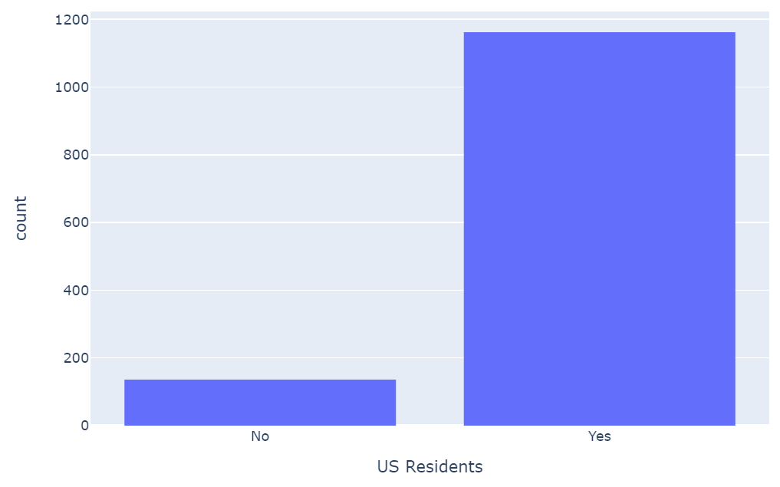

How many individuals contribute to your household income?

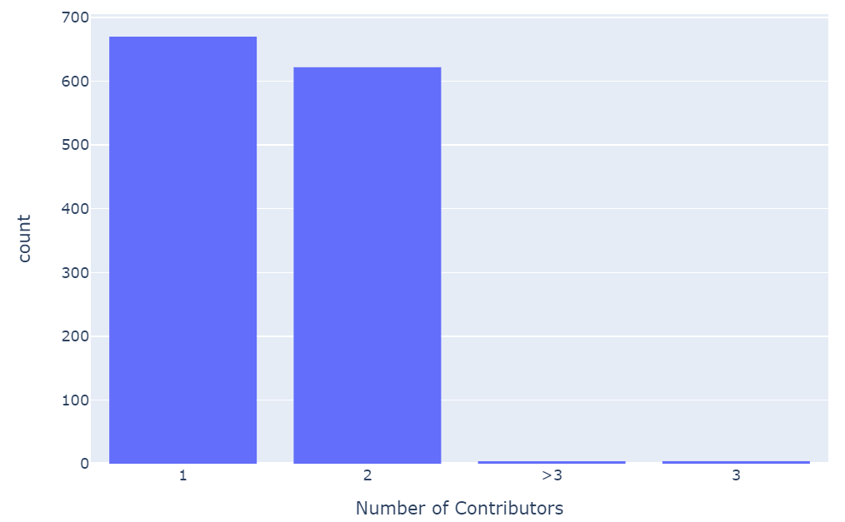

What point approximates your political views (1 – 100, left – right)?

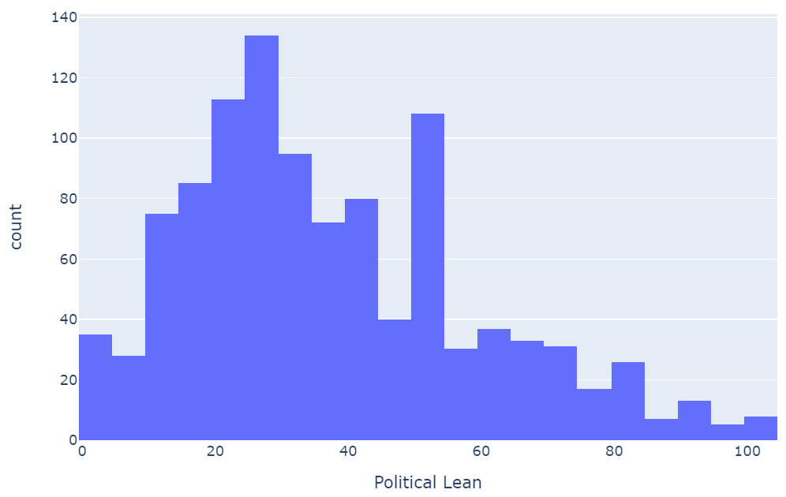

What is your race/ethnicity (primary)?

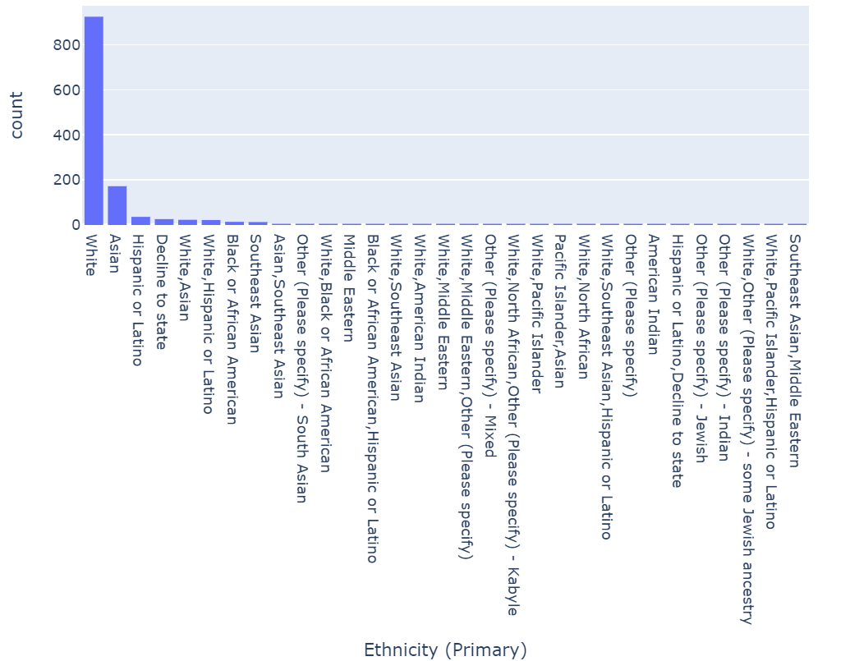

What is your race/ethnicity (secondary)?

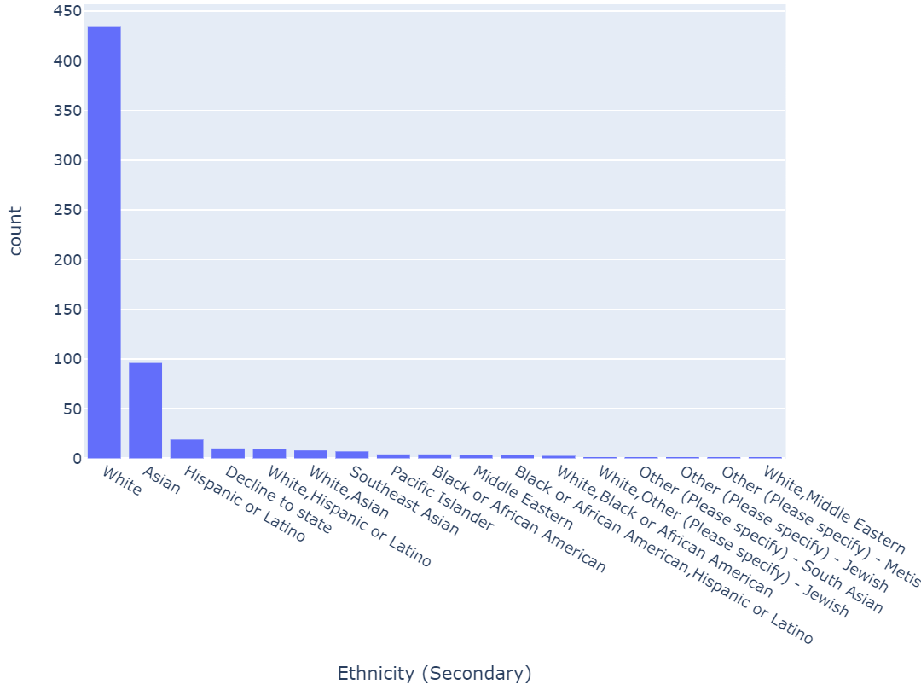

What is your gender (primary)?

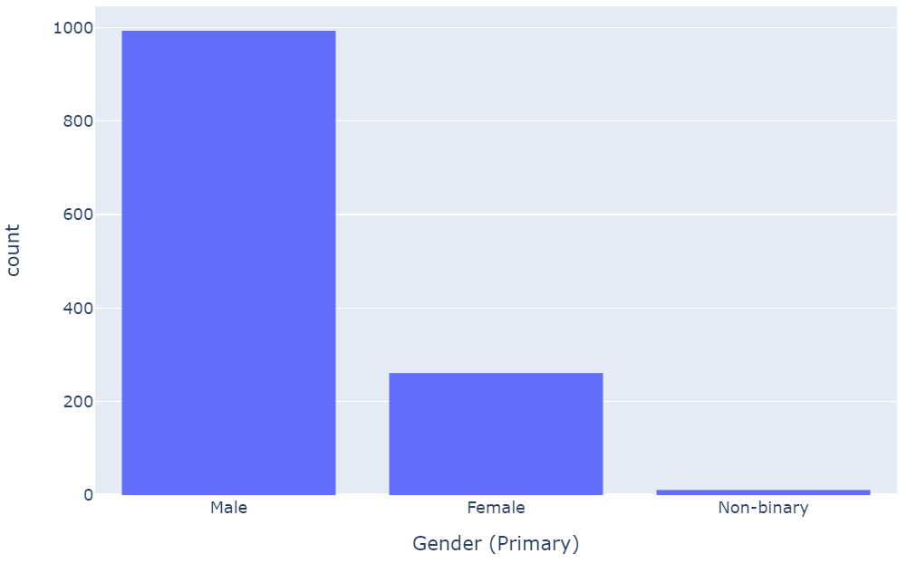

What is your gender (secondary)?

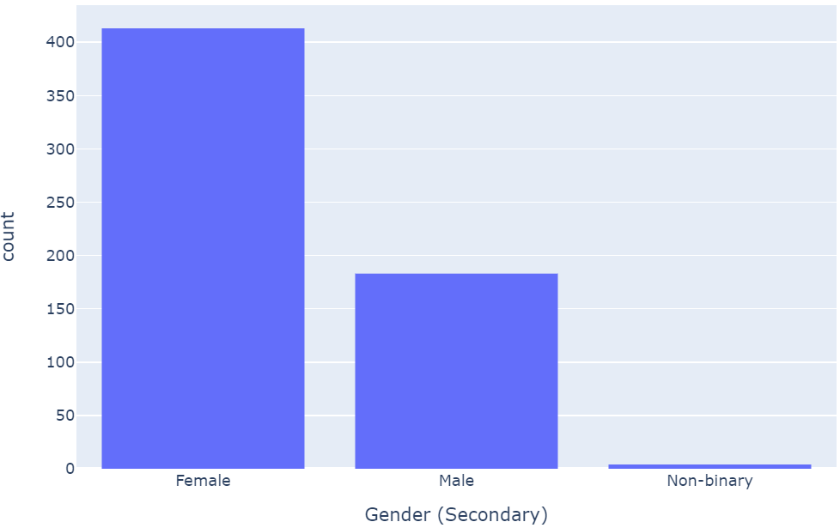

What is your age (primary)?

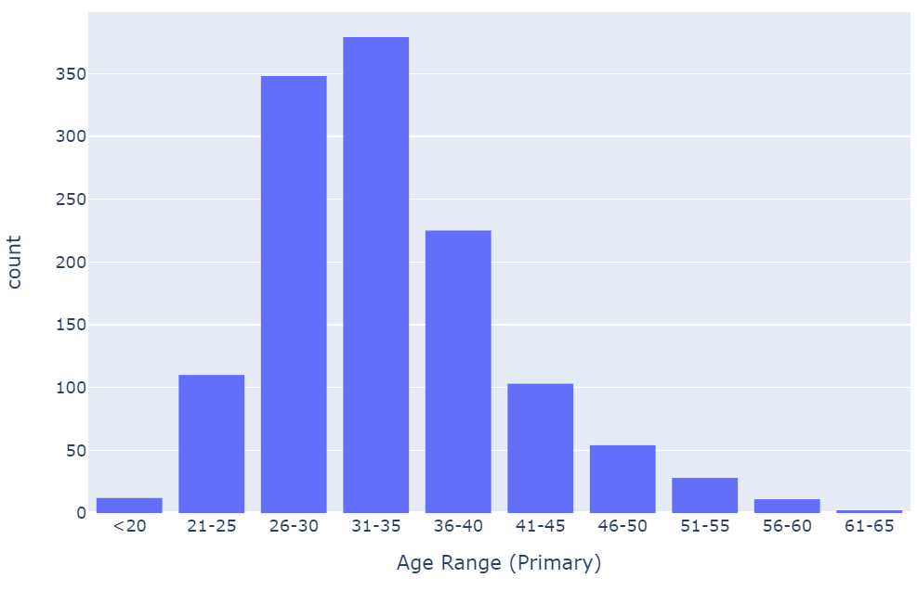

What is your age (secondary)?

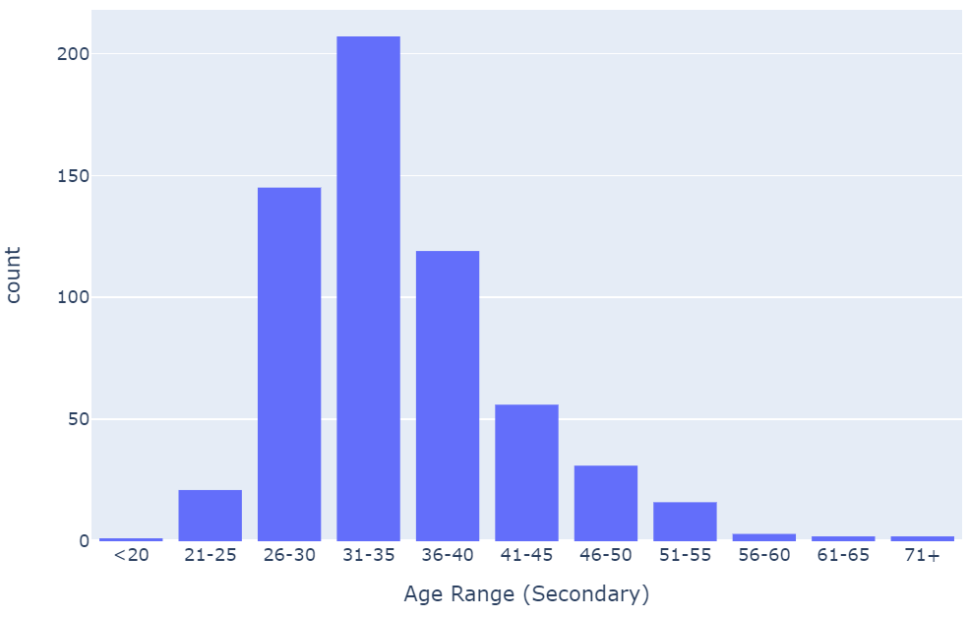

What is your relationship status (primary)?

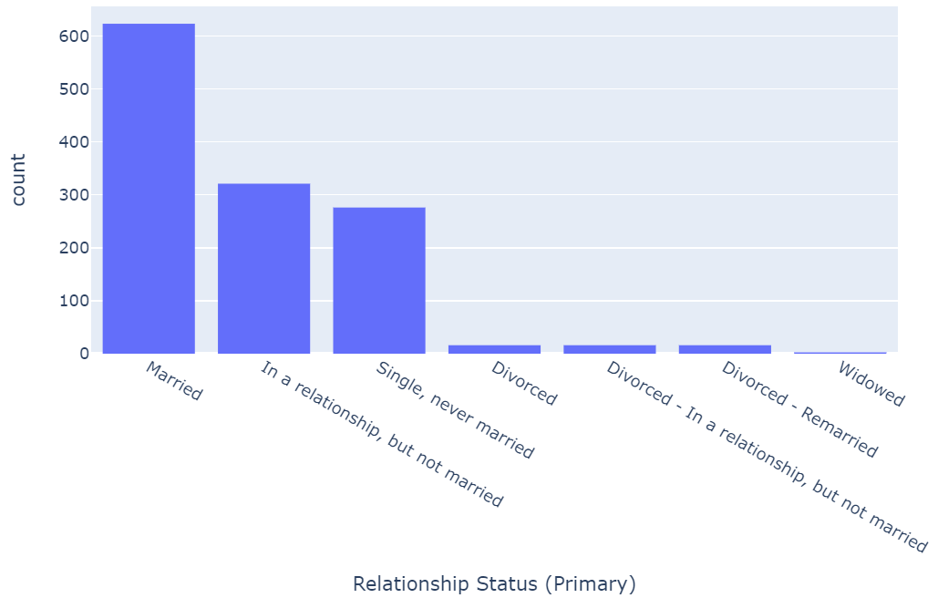

Do you have or plan to have children?

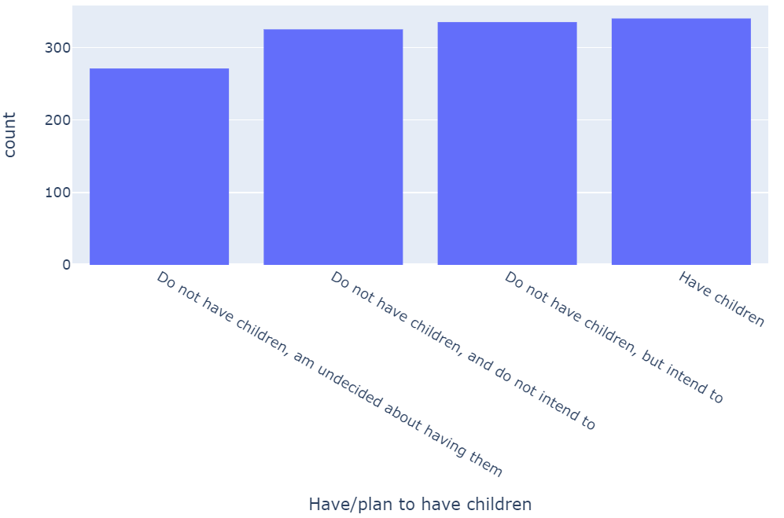

How many children do you have?

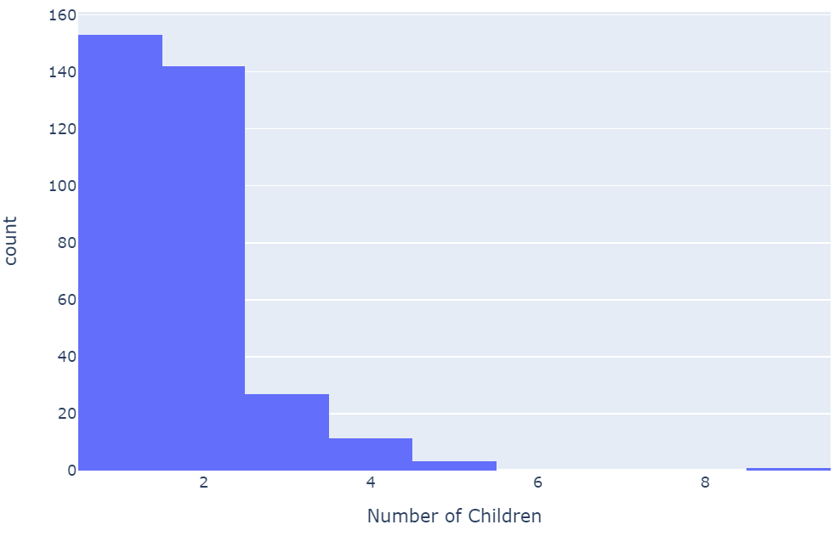

How many children do you still want to have?

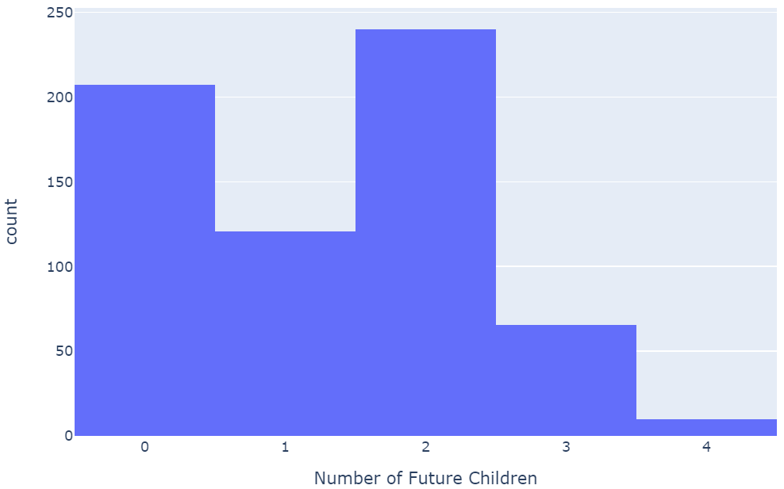

What is your highest level of education (primary)?

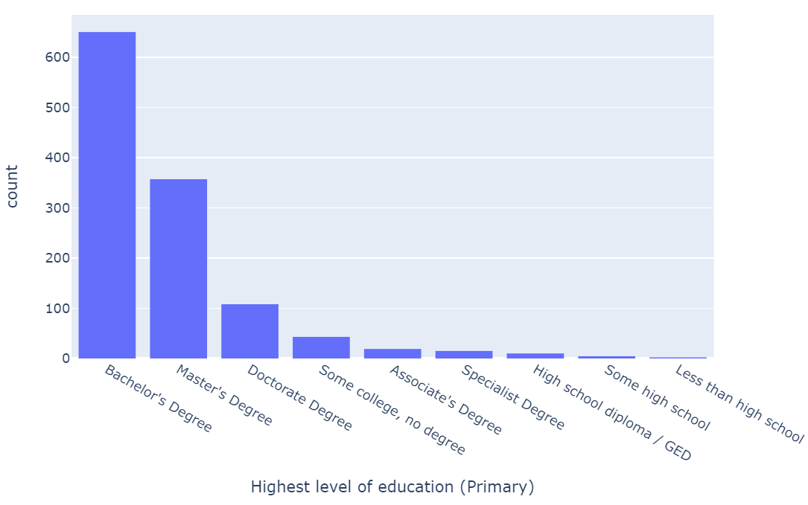

What is your highest level of education (secondary)?

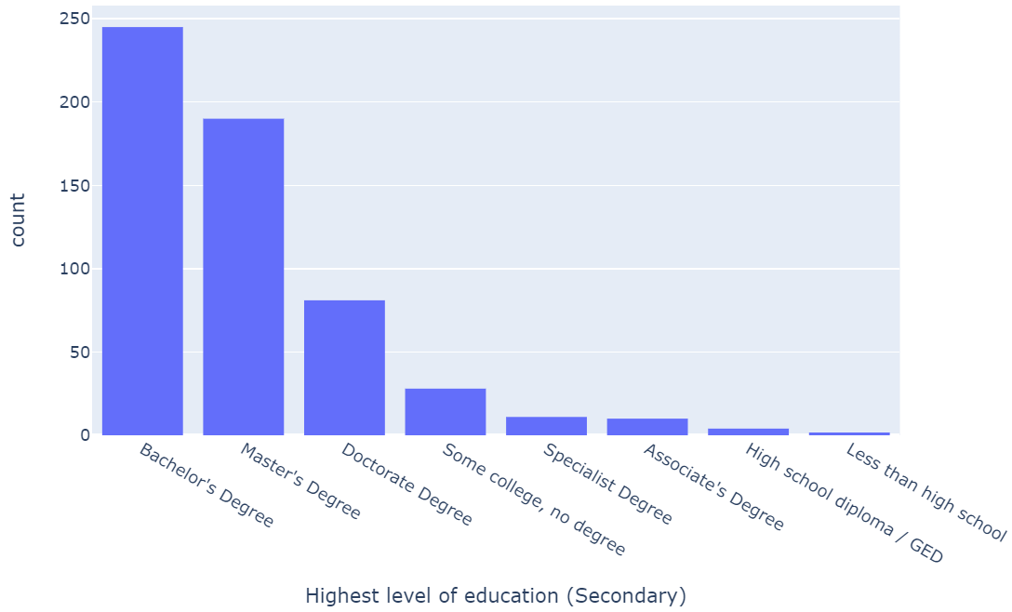

What best describes your field of work (primary)?

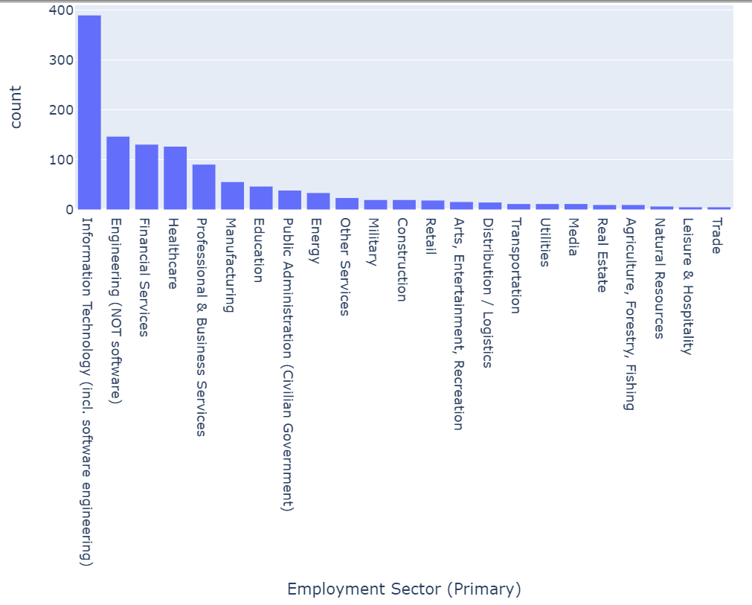

What best describes your field of work (secondary)?

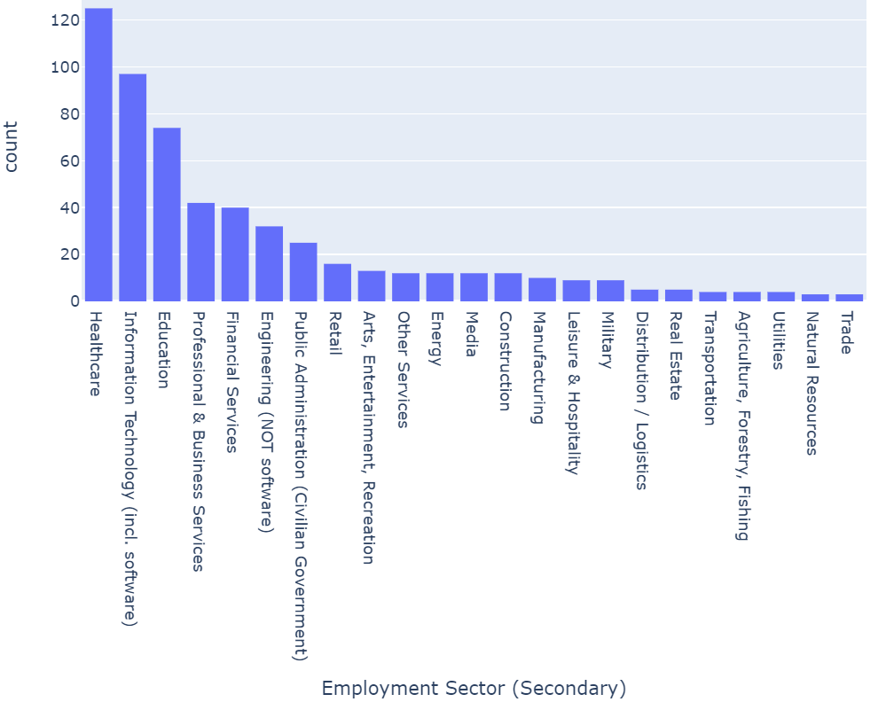

What best describes your current employer (primary)?

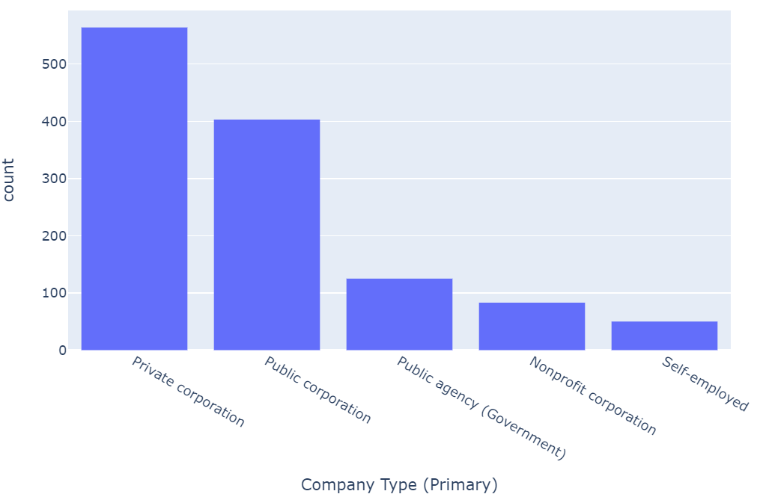

What best describes your current employer (secondary)?

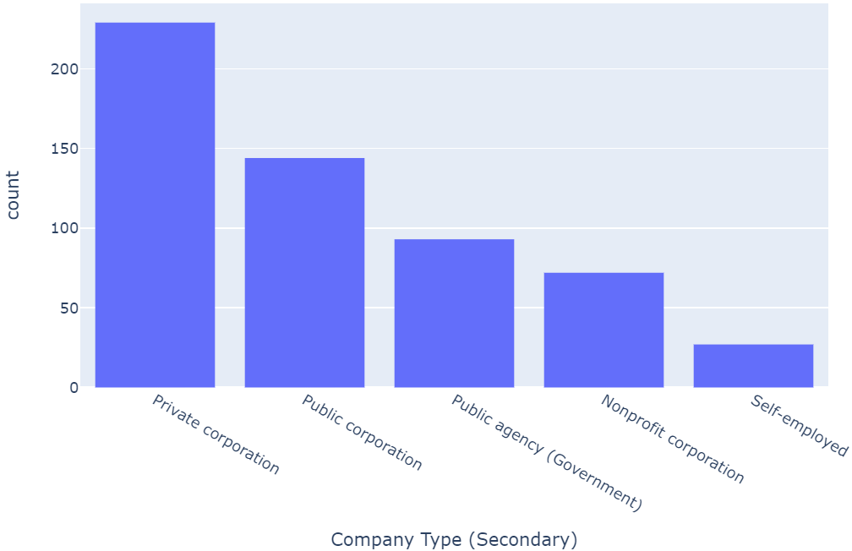

What is the cost-of-living index of your area of residence?

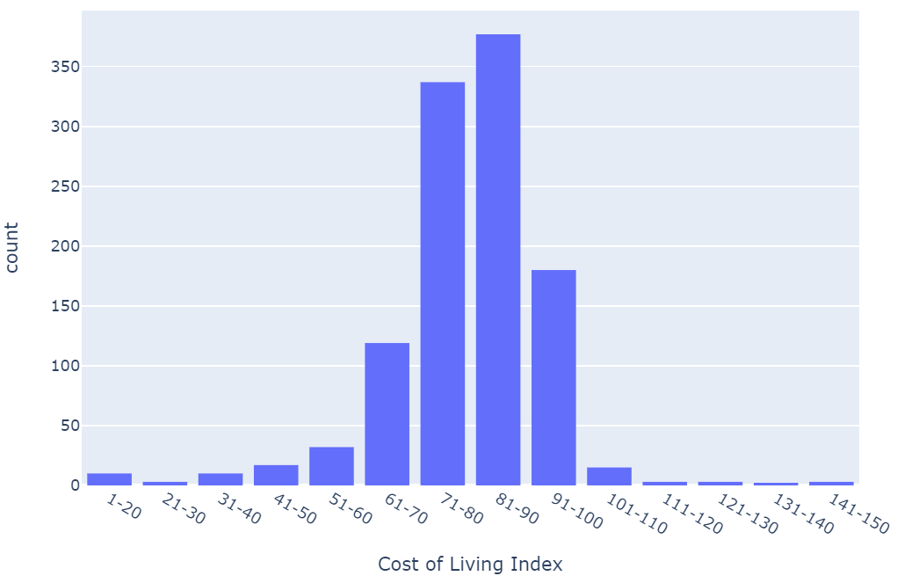

What is your current housing situation?

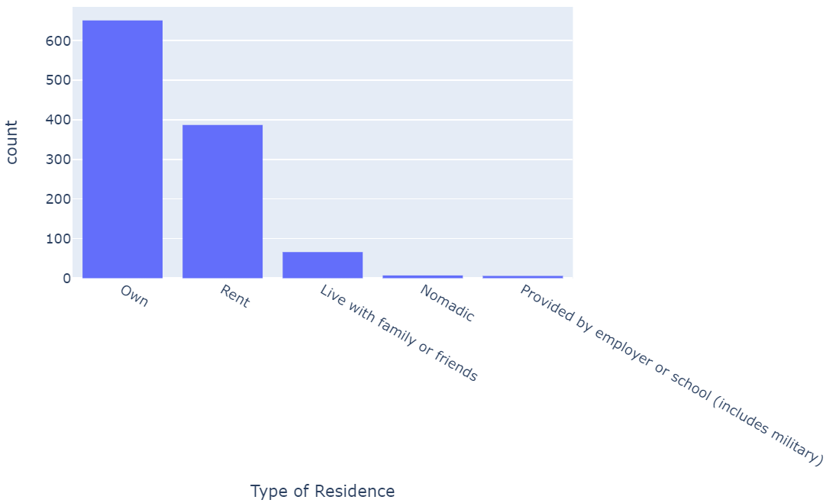

Are you considered financially independent?

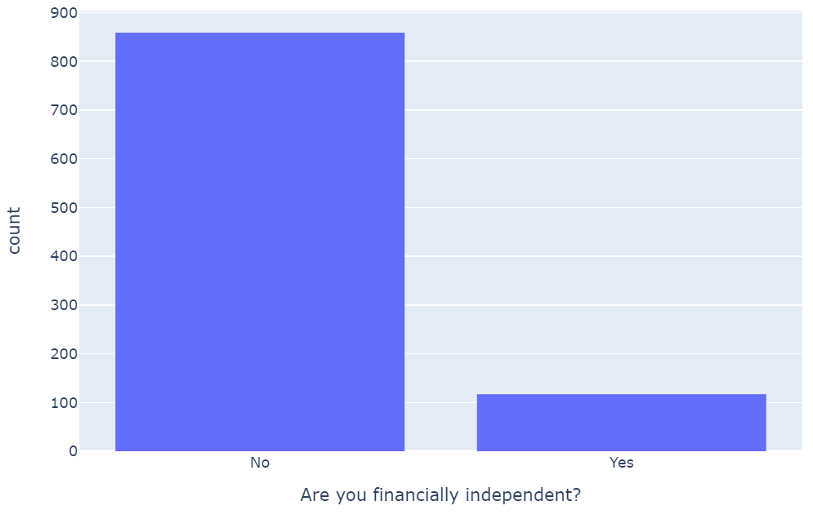

Those who are financially independent, are you retired?

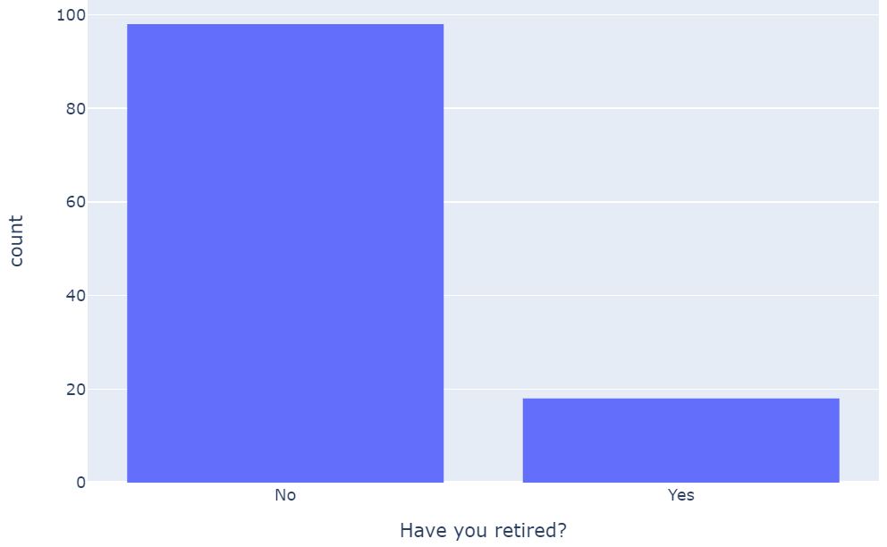

Will you retire once you hit financial independence?

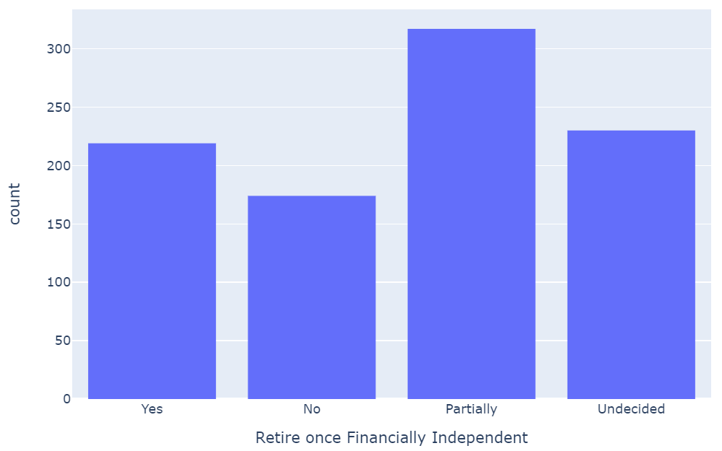

At what age do you expect to retire (Non-FI respondents)?

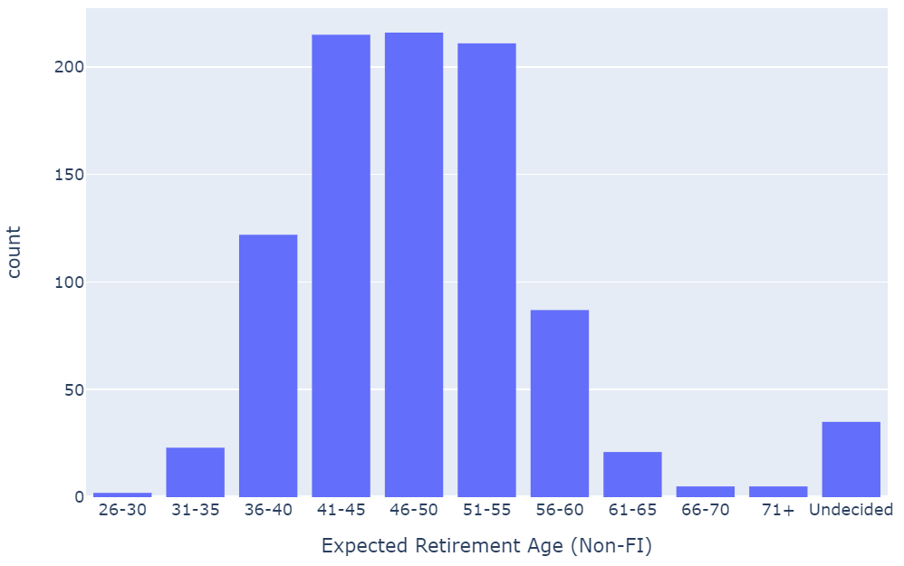

At what age do you expect to retire (FI respondents)?

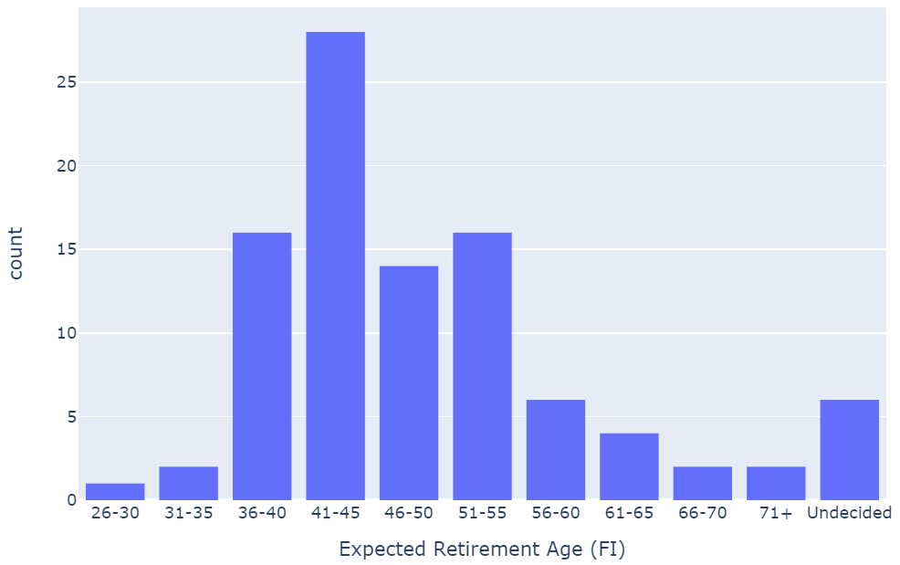

What is your targeted safe withdrawal rate?

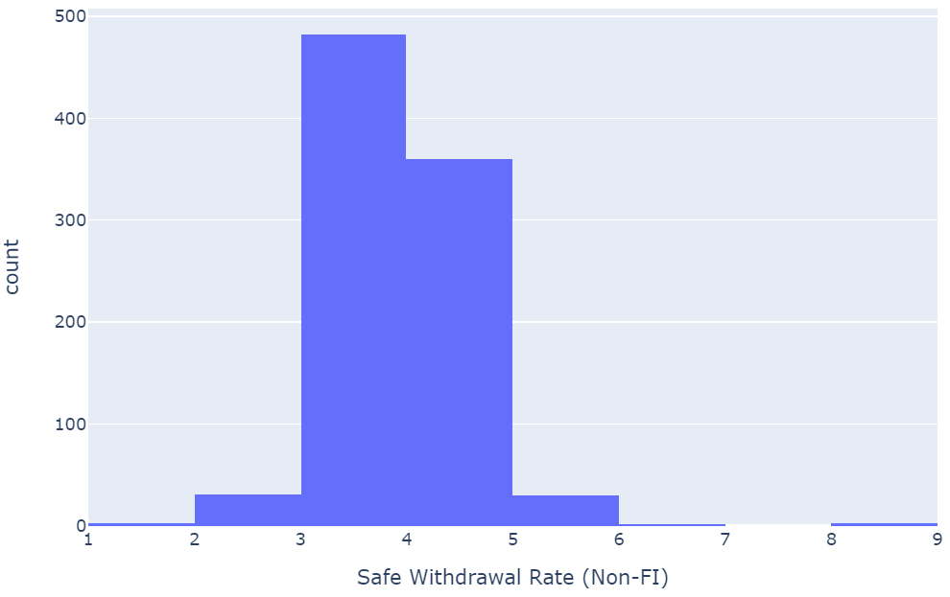

What is your financial independence number?

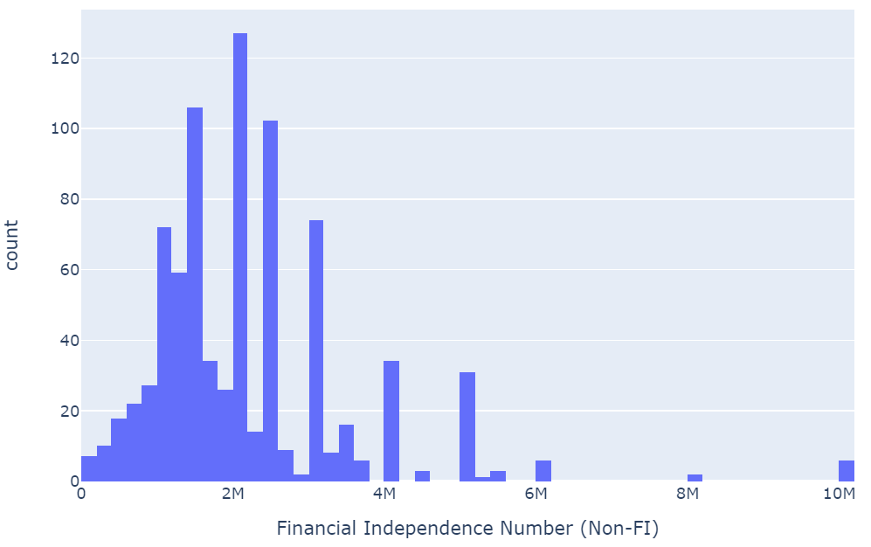

What is your early retirement number?

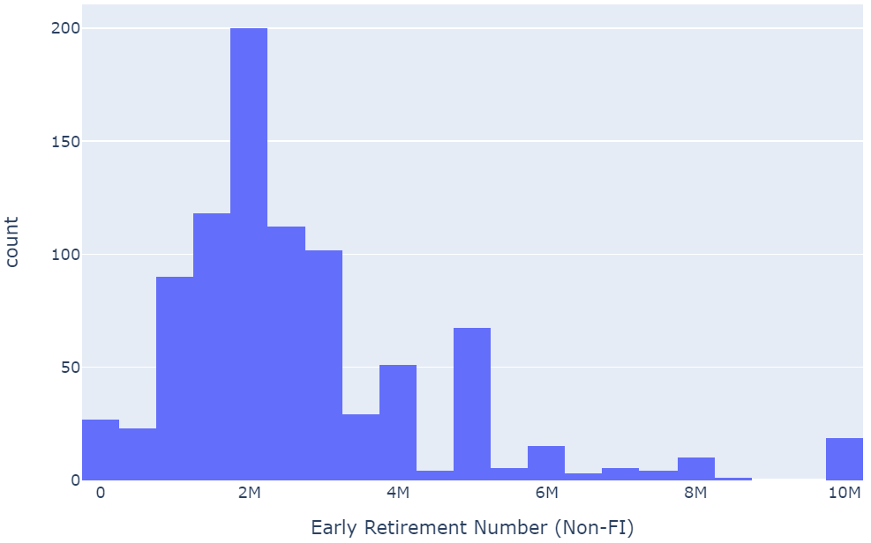

What percent of your financial independence number are you currently at?

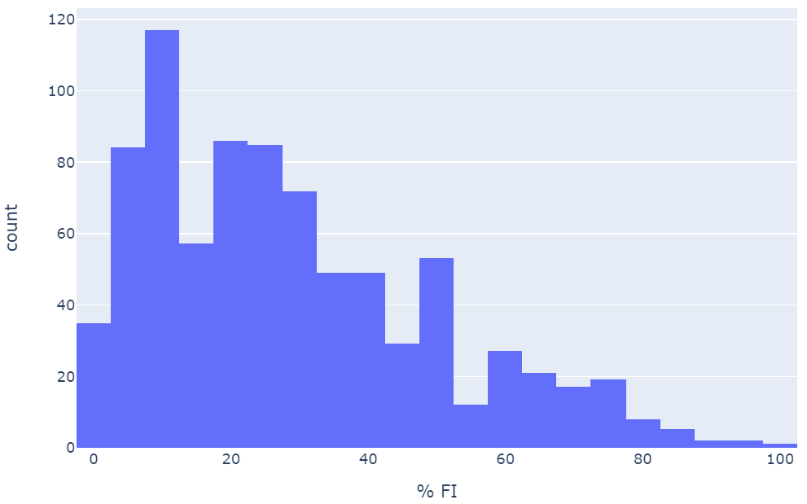

What is your expected annual income in retirement?

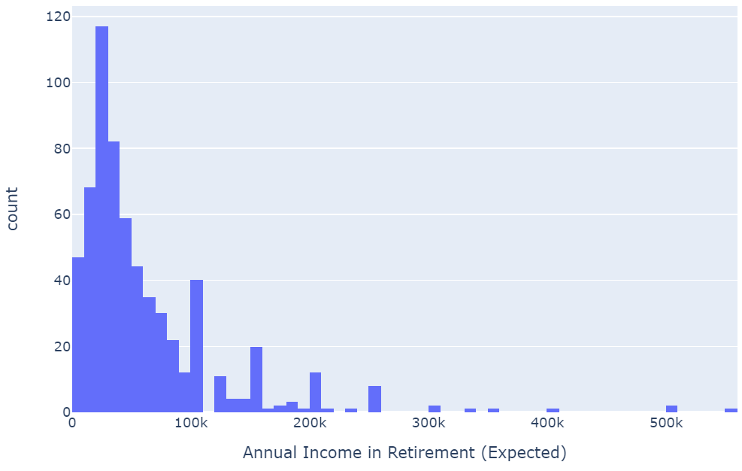

What are your expected annual expenses in retirement?

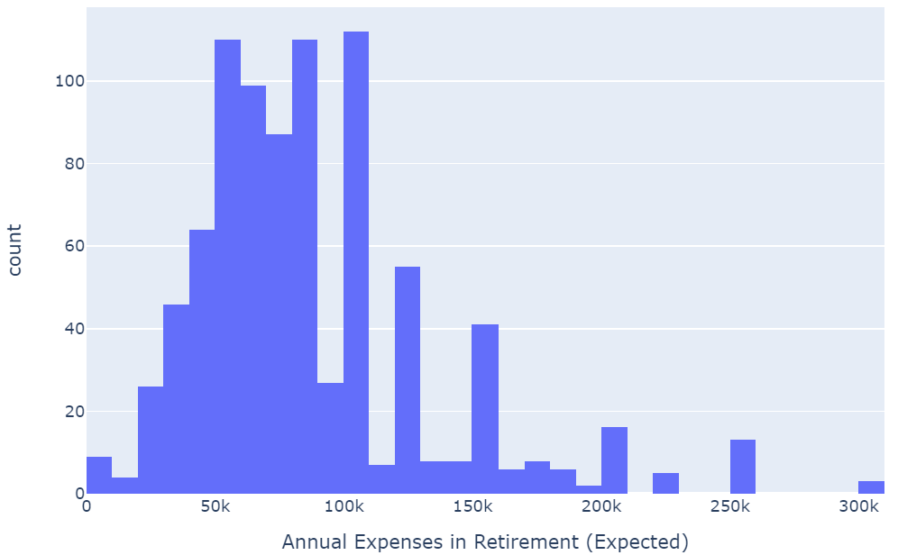

What is your total annual income?

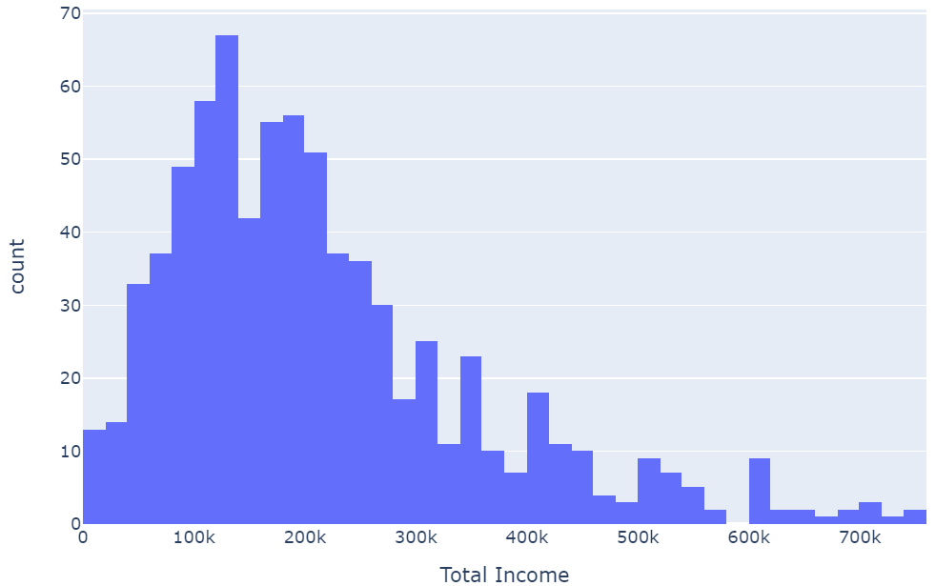

What are your total annual expenses?

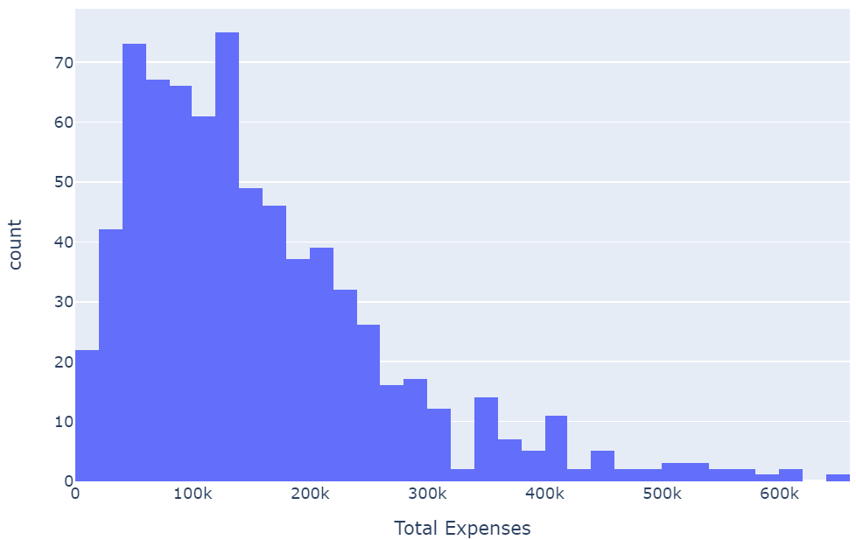

How much total debt do you have?

